Sample Midterm
- Activation and loss functions help transform a model to fit nonlinear spaces
True / False
- Softmax function transforms a set of K numbers into outputs between 0 and 1
True / False
- What is the primary role of an activation function in a neural network?
- To compute the weighted sum of inputs
- To initialize the weights of the neurons
- To introduce non-linearity to the model
- To calculate the loss during training
- To determine the number of layers in the network

4. What will be the shape of tensor c after executing the following code?
a = torch.tensor([[1, 2, 3],
[4, 5, 6]])
b = torch.tensor([[7, 8, 9]])
c = torch.cat((a, b), dim=0)
- (2, 3)
- (3, 3)
- (1, 9)
- (3, 2)

5. Describe the three versions of the gradient descent algorithm (Stochastic Gradient Descent, Mini-batch Gradient Descent, and Batch Gradient Descent), discuss their differences

6. Imagine you are building a content moderation system for a social media platform that needs to detect toxic comments. You have access to a small 400-example dataset of comments labeled as "toxic" or "non-toxic". Design a system that can effectively moderate content.
- How would you define the problem? What would be the input and output of your model?
- What kind of model and loss function would you choose and why?
- What are some things you would do to ensure the training of a good (and robust) model?
7. 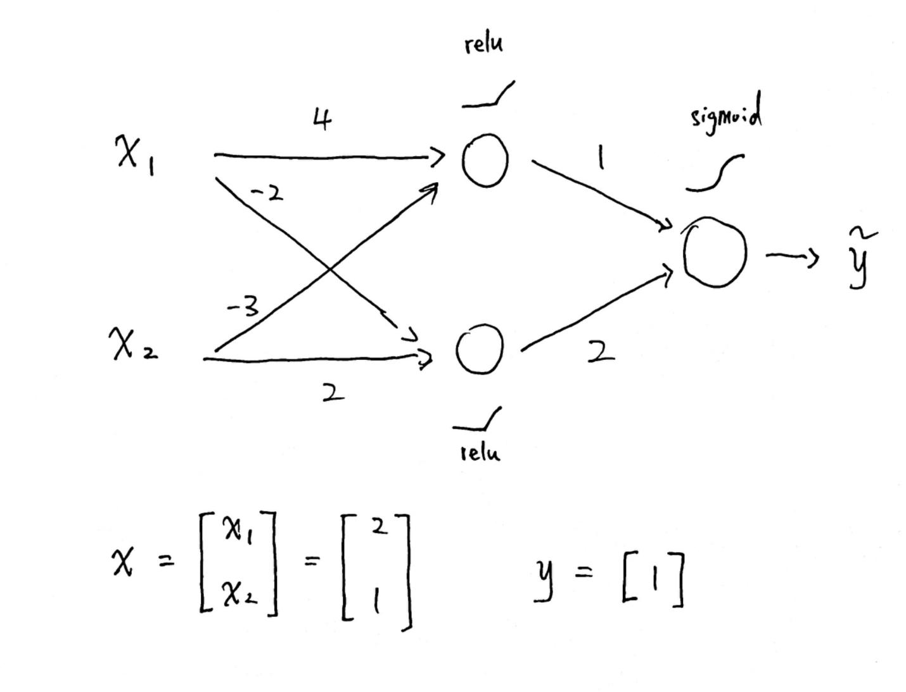
Suppose you have this MLP(used the natural log)
- Calculate the BCE loss
- Write down the formula to calculate the gradient of the loss with respect to W² (the weight matrix of the second layer)
- Evaluate the formula using the given value

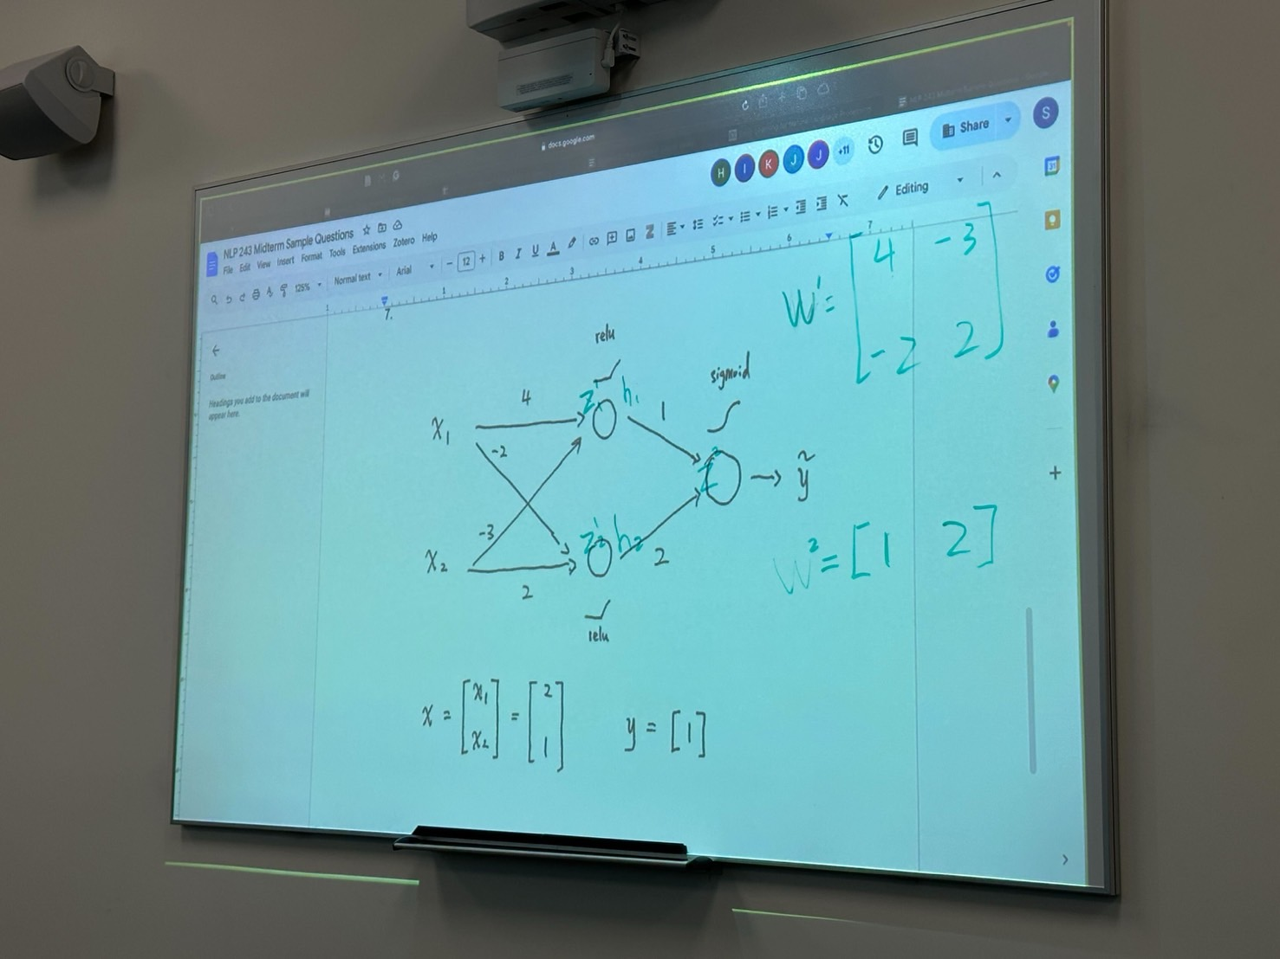
Ans 7:

